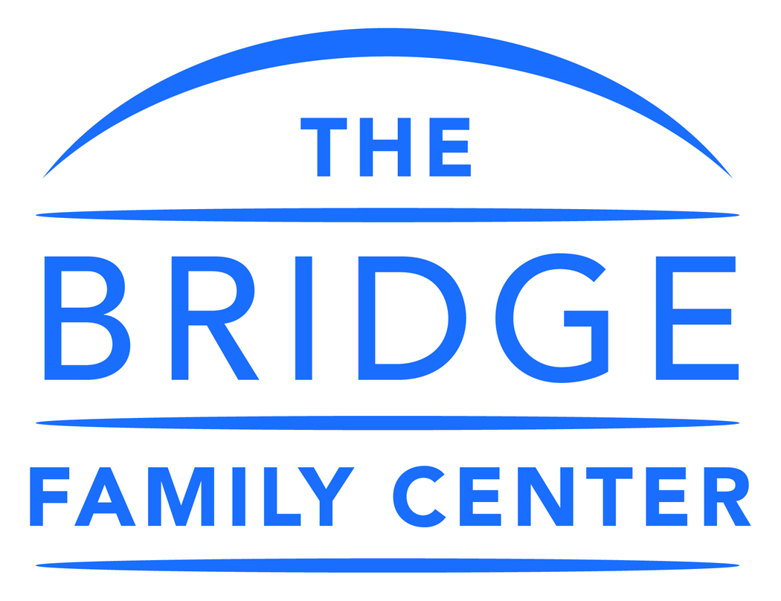

CREDIT CARD AUTHORIZATION

Adult Client Name: ___________________________________________________________________________
Parent/Guardian Name:
Child’s Name:
Address:
Daytime Phone: Email address:
Cell Phone: Evening Phone:
I give permission for The Bridge Family Center to charge my credit card for Bridge services.

Name as it appears on the card:

PLEASE NOTE THAT CHARGES TO YOUR ACCOUNT FOR RECURRING CREDIT CARD TRANSACTIONS MAY OCCUR AT ANY TIME ON THE DESIGNATED PAYMENT DATE(S).
If the credit card is declined, a $25 fee maybe charged. Contact us with an alternate payment option.

Print Name

Signature Date:

